Internship Report - Day 4
Name : Rickshtiha A
Intern ID : CDM/INT/202607608
Topic: Introduction to Pandas and Dataset Exploration
Objective
The objective of Day 4 was to learn the basics of the Pandas library and understand how to load, explore, and analyze a dataset. The session focused on importing Pandas, loading a student score dataset, viewing rows and columns, and obtaining dataset information.

Tasks Completed
- Installed and imported the Pandas library.
- Loaded the student score dataset.
- Viewed the first and last records of the dataset.
- Explored rows and columns.
- Checked dataset information.
- Displayed statistical summary of the dataset.
- Identified missing values.

Introduction to Pandas
Pandas is an open-source Python library used for data analysis and data manipulation. It provides powerful data structures like Series and DataFrame, making it easy to work with structured datasets.
Advantages of Pandas
- Easy to read CSV and Excel files
- Fast data analysis
- Handles missing values efficiently
- Supports filtering and sorting
- Widely used in Data Science and Machine Learning

Student Score Dataset
Example Dataset (student_scores.csv)
Student_ID | Name | Maths | Science | English
101 | Asha | 85 | 90 | 88
102 | Rahul | 78 | 82 | 80
103 | Priya | 92 | 95 | 94
104 | Arun | 74 | 70 | 72
105 | Divya | 89 | 91 | 90

Topics Learned
1. Importing Pandas
import pandas as pd

2. Loading the Dataset
import pandas as pd

df = pd.read_csv("student_scores.csv")

3. Display First Five Rows
print(df.head())
Output
Student_ID Name Maths Science English
0 101 Asha 85 90 88
1 102 Rahul 78 82 80
2 103 Priya 92 95 94
3 104 Arun 74 70 72
4 105 Divya 89 91 90

4. Display Last Five Rows
print(df.tail())

5. Display Dataset Information
print(df.info())
Output
<class 'pandas.core.frame.DataFrame'>
RangeIndex: 5 entries, 0 to 4
Data columns (total 5 columns)

6. Display Column Names
print(df.columns)
Output
Index(['Student_ID', 'Name', 'Maths', 'Science', 'English'], dtype='object')

7. Display Dataset Shape
print(df.shape)
Output
(5, 5)
The dataset contains:
- 5 Rows
- 5 Columns

8. Statistical Summary
print(df.describe())
This displays:
- Count
- Mean
- Standard Deviation
- Minimum Value
- Maximum Value
- Quartiles

9. Check Missing Values
print(df.isnull().sum())
Output
Student_ID 0
Name 0
Maths 0
Science 0
English 0
There are no missing values in the dataset.

Programs Practiced
Program 1 – Load Dataset
import pandas as pd

df = pd.read_csv("pos_tags.csv")

print(df)

Program 2 – Display Dataset Information
import pandas as pd

df = pd.read_csv("pos_tags.csv")

print(df.info())

Program 3 – Display Column Names
import pandas as pd

df = pd.read_csv("pos_tags.csv")

print(df.columns)
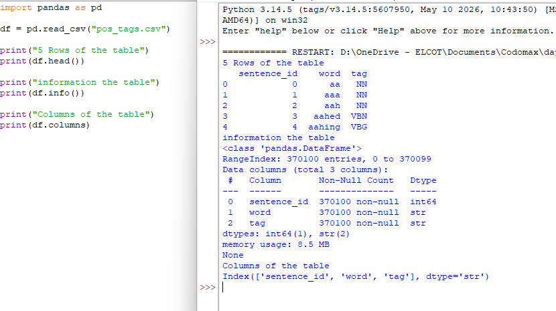
Applications of Pandas
- Data Cleaning
- Data Analysis
- Machine Learning
- Artificial Intelligence
- Data Visualization
- Business Intelligence
- Financial Analysis

Learning Outcome
On Day 4, I gained practical knowledge of the Pandas library and learned how to load and explore datasets efficiently. I understood how to inspect dataset structure, retrieve rows and columns, generate statistical summaries, and check for missing values. These skills form the foundation for data preprocessing and analysis in Machine Learning and Artificial Intelligence projects.

